Name: Mudit Mohit **Assignment 5**

Enrolment No.: BT21GCS057

Section: B2

Q4.) Write a program to sort an array of integers using the insertion sort algorithm. At last, analyse the program over the following operations:

1. List is in sorted order
2. List is in unsorted order
3. What is the best-case and worst-case complexity of your program?

Ans.

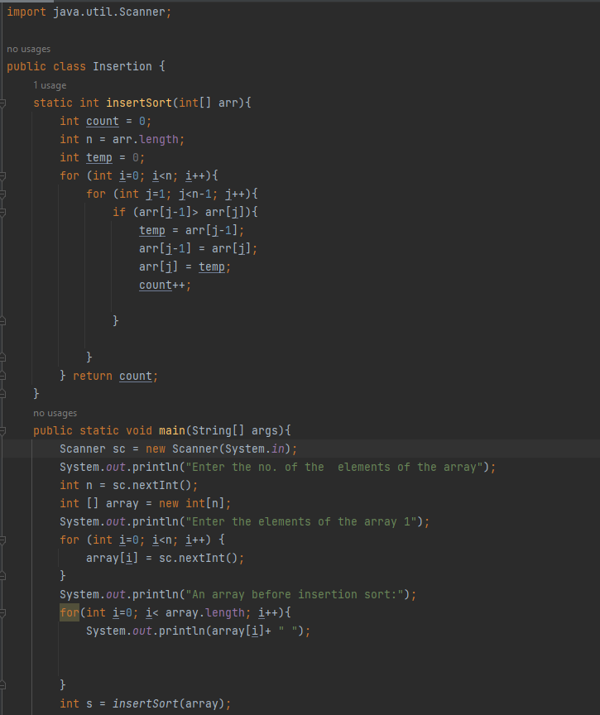

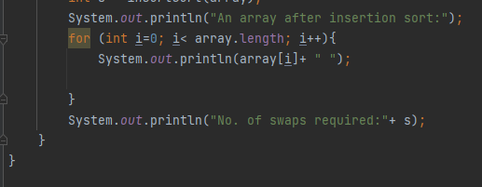

Output:

Best-case:

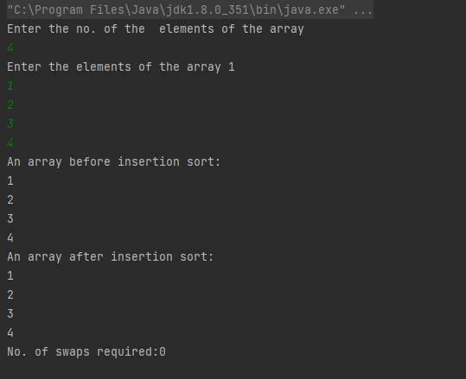

Average-case:

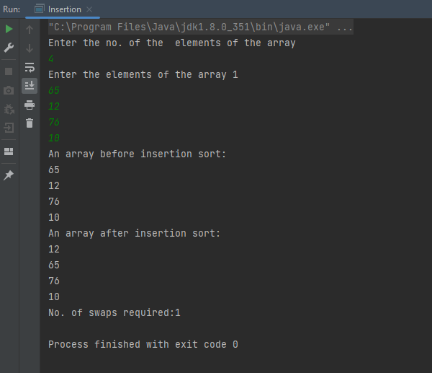

Worst-case:

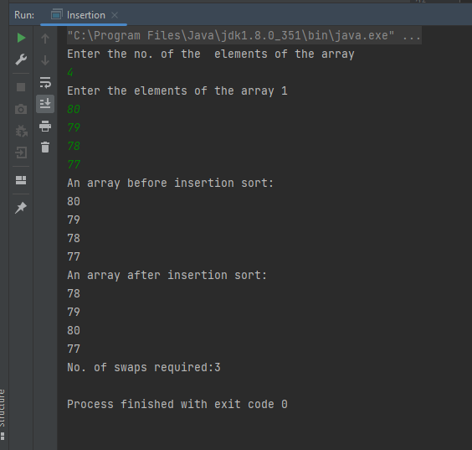

Time-complexity:

For the average and worst case, time complexity = O(n^2)

For best case = O(n)